Birkenfeld, March 2016

Internorga 2016 – 11 to 16 March, Messe Hamburg – hall B7, booth 409

The set table: a few deft touches, a tremendous effect

WMF and TAFELSTERN bring metal and glass and porcelain into harmony – 'Gastronomiedesign' published

The set table is gastronomy’s acting stage. Because it is the scenery for culinary enjoyment – the odours and tastes of the dishes combine with the aesthetics and haptics of glassware and cutlery, porcelain, table linen and accessories. Even the tiniest constituent has its part to play in the overall composition – be it as neutral accompaniment or attention-grabbing highlight. "What never ceases to amaze me is how just a few deft touches create a completely different mood", says Susanne Schmidt, Marketing Director of proHeq GmbH. "And of course the huge playing field that porcelain, glass and metal create when juxtaposed." Against this background, the joint customer service of WMF and TAFELSTERN supports clients from all the varying sectors of the hospitality industry. A big plus is the ability to offer customer-friendly, all-inclusive solutions from a single source, satisfying the requirements of widely differing gastronomic concepts. The table arrangements from the two partners dovetail with a neatness aptly depicted in "Gastronomiedesign", the new book by Ms Hanna Raissle, renowned ambience coach and designer for the gastronomy and catering world. The book is published by Matthaes Verlag and appeared in early February 2016.

On 150 pages, "Gastronomiedesign" explains how a perfect arrangement for casual or fine dining is developed in its entirety. The book takes a more comprehensive approach than the body of comparable literature: it considers the set table and everything that belongs to it not just as an essential room factor but also as a profit maximiser. "To my mind it is particularly important to build bridges between conveyors of mood – by that I mean colours, materials and shapes – and major profitability factors, such as the guest's length of stay at the table", explains author Hanna Raissle. "First to last, this book reflects the concept that underlies our cooperation, namely to bring metal, glass and porcelain for the set table into harmony. That's why we are so happy to be part of this all-inclusive compendium", says Susanne Schmidt. Products from WMF and TAFELSTERN feature in the pictures shot for the book by award-winning photographer Erol Gurian – a small foretaste follows.

Vernal midday table – linearity creates structure
Clear lines and discreetly placed accessories create harmony of composition in this gastronomic concept. The puristically elegant plate design of the Pure Style line from TAFELSTERN is continued in the Solid cutlery collection from WMF Professional. The high-quality dark oakwood of the table light and flower vase from the Pure Exclusiv by WMF Professional are touches of sophistication. Table runners in glowing red are the perfect framing for this mutedly low-keyed arrangement.
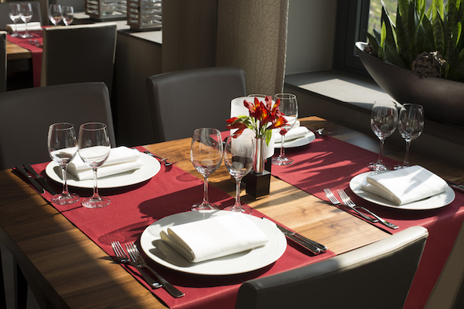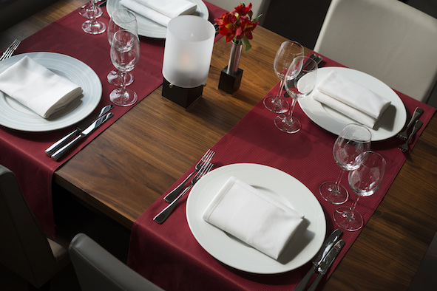

Festive atmosphere – avant-garde versus simplicity
Special occasions call for special table culture. The set table is really dressed up when adorned with the Juwel cutlery model from WMF Professional, with its physical vapour deposition (PVD) finish in golden tone (left). Artfully arranged on an elegant table runner, the droplet shaped porcelainware from the Avantgarde collection by TAFELSTERN creates an expressive overall ambience. Totally different, but no less festive, is the Flair cutlery line from WMF Professional together with the Essentials porcelainware from TAFELSTERN in the photo right. Spectacular accessories such as cloches and candle-holders contribute simple elegance to the atmosphere of the set table.
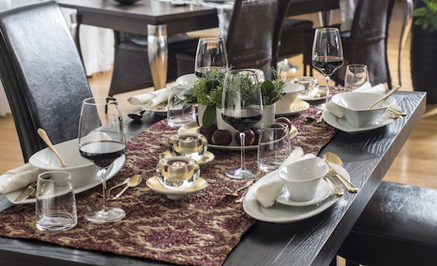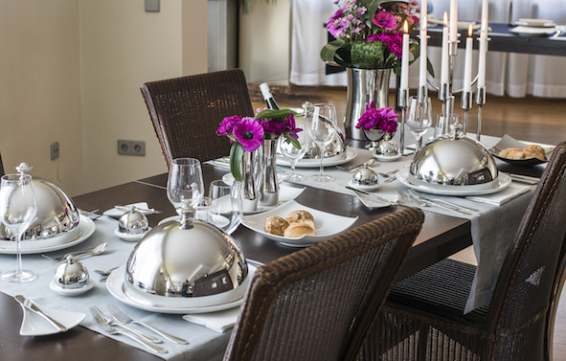

Photo request
You will find images for download on our media portal http://press-n-relations.amid-pr.com search term „Gastronomiedesign“. We will also be pleased to send you this file by e-mail on request. Contact: wmf@press-n-relations.de.
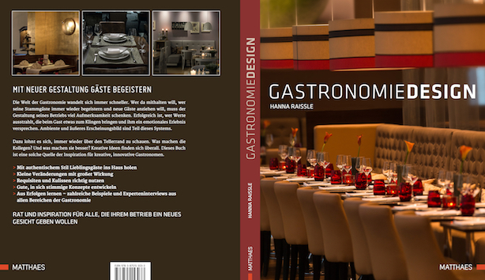

Additional information:  WMF Group GmbH  Thomas Dix, press spokesman  Eberhardstraße - 73309 Geislingen  Tel.: +49 73 31 25 8386  Fax: +49 73 31 25 8061  thomas.dix@wmf.de – www.wmf.de | Press and public relations:  WMF press agency  c/o Press’n’Relations GmbH  Vanessa Klein and Monika Nyendick  Magirusstrasse 33 – D-89077 Ulm, Germany  Tel.: +49 731 96287-30 – Fax: +49 731 96287-97  wmf@press-n-relations.de – www.press-n-relations.de

About the WMF Group
WMF Professional Business Unit Hotel is one of the leading suppliers of professional hotel, catering and hospitality equipment. Stylish, high-quality complete solutions for every aspect of the art of presenting and serving food and beverages is the hallmark of the long-established brand. The extensive range includes cutlery and glassware, serving trolleys, buffet equipment and table-top decorations of every complexion.

For more than 160 years, the brands that make up the WMF Group have represented the best in cooking, drinking and dining. Every day, hundreds of millions of people around the world use WMF, Silit and Kaiser products to prepare food, cook, bake, eat and drink in the comfort of their own home. And when they are not doing that, they are enjoying coffee specialities and foods prepared by the hotel and catering industry using products from WMF, Schaerer or Hepp. Our employees are passionate about bringing people together, whether at home, on the move or at high-end restaurants, in order to give them shared moments that are both precious and delicious. This is all possible thanks to our products, whose exceptional design, perfect functionality and highest quality provide wonderful culinary experiences. Our company has a proud tradition, and was founded in Geislingen an der Steige in Germany back in 1853. Almost 6,000 employees provide culinary joy at more than 40 locations worldwide. The WMF Group achieved sales of EUR 1,024.3 million in 2014.

Additional information:  TAFELSTERN • professional porcelain  A brand of BHS tabletop AG  Ludwigsmuehle 1 – D-95100 Selb  Phone: +49 9287 73 1711  Fax: +49 9287 73 1719  info@tafelstern.de | Press and public relations:  AGENTUR 21  Julie Ulrike Lanz  Lindenstrasse 82 – D-50674 Cologne  Phone: +49 221 210061 – Fax: +49 221 210063  tafelstern@agentur-21.de -  www.agentur-21.de

About Tafelstern
Tafelstern is an independent brand of BHS Tabletop AG, world market leader for professional porcelainware. As a global-player brand for ambitious, quality catering and hospitality, the company stands for table culture on the highest level and the art of staging culinary enjoyment.
Manufacturing design-perfect professional porcelainware made in Germany means committing to flawless, outstandingly durable product quality, and to achieving consummate design in form and decoration. Tafelstern's unique modular system makes porcelainware from different collections freely combinable.
This professional porcelainware made in Germany is marketed to clients in Germany directly by WMF Group GmbH, Geislingen, or via the webshop at www.tafelstern.de. Interested parties from outside Germany will find the international contact data posted on the website.

