Birkenfeld, March 14, 2014

Internorga 2014 – 14. - 19. March 2014, Hamburg – Hall B7, Stand 409

The right foundation for every coffee speciality

WMF Hotel presents the new “CultureCup” collection

Pure, modern design and numerous combination possibilities for the basic items score very highly for the new “CultureCup” collection from WMF. As proven with the “CoffeeCulture” line, these items can be put to work in a number of ways and offer the perfect foundation for every coffee speciality. And there’s more: with re-designed cup sizes, completely new sets and an alternative base form, variety is the spice of life on cafe and restaurant tables everywhere. With a total of 84 pieces, from spoons and serving trays to latte macchiato glasses, the “all-rounder set” has everything that a host could want when it comes to serving coffees, teas and cocoa and is therefore the ideal starter set. There are, of course, also smaller sets for cappuccino, espresso, and other such delights.

Along with harmonious design, which visually accentuates the enjoyment of coffee, functionality is also at the core of the CultureCup concept. This is clear from the choice of easy-care materials such as Cromargan stainless steel 18/10 and robust porcelain, but is also reflected in the style of the glasses and cups. Rather than having a plenty of individual pieces, the porcelain items are available in three specific sizes. These have been designed in such a way that they can be used in many different settings, whilst also allowing specialities to be served perfectly. The tall size M cups, for example, are ideal for serving café crème or filter coffee. The flat design of this size is a new introduction to this range and is specially designed for serving cappuccino. At the same time, tea blends or hot chocolates can also be elegantly presented. The standard tray in the CultureCup collection offers space for all cup sizes , as well as an accompanying glass of water, a pastry, milk or sugar – whatever the customer or host requires.

A further highlight is the size S cup, which fits perfectly into the inserts and stands from the WMF Pure and Pure Exclusiv ranges, meaning they can also be combined with both tabletop series, thus unleashing yet more creative freedom. What’s more, all items in the CultureCup collection are also dishwasher safe, and the handles and cups can be washed separately from one another.

Photo request
You will find images for download on our media portal http://press-n-relations.amid-pr.com using the search term „CultureCup“. We will also be pleased to send you this file by e-mail on request. Contact: wmf@press-n-relations.de

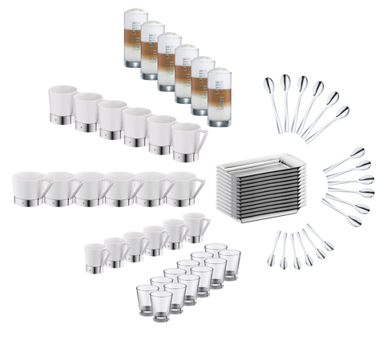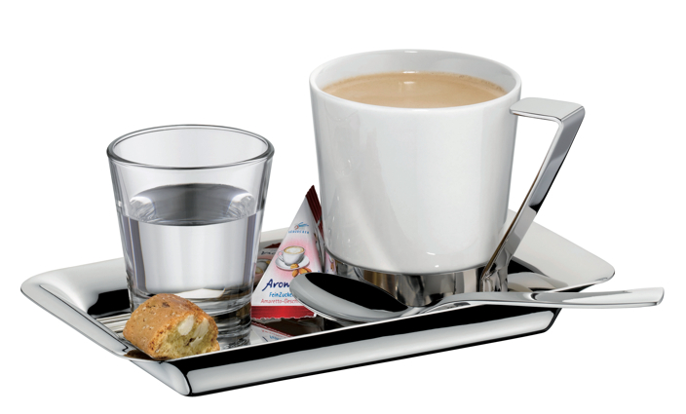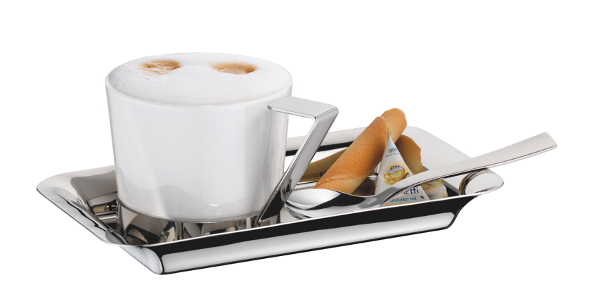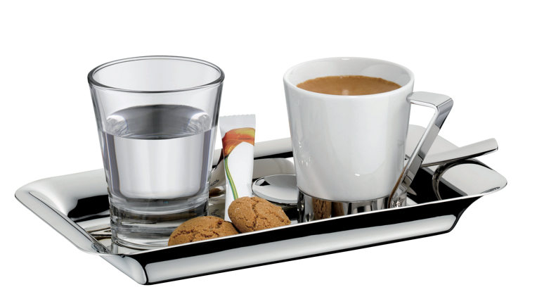

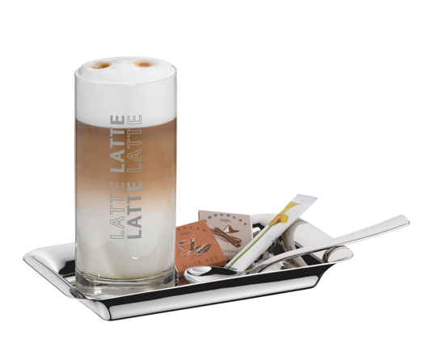

Additional information:  WMF Group GmbH  Thomas Dix, press spokesman  Eberhardstraße - 73309 Geislingen  Tel.: +49 73 31 25 8386  Fax: +49 73 31 25 8061  thomas.dix@wmf.de – www.wmf.de | Press and public relations  WMF press agency  c/o Press’n’Relations GmbH  Vanessa Klein and Monika Nyendick  Magirusstrasse 33 – D-89077 Ulm, Germany  Tel.: +49 731 96287-30 – Fax: +49 731 96287-97  wmf@press-n-relations.de – www.press-n-relations.de

About WMF Group
WMF Hotel is one of the internationally leading suppliers of professional hotel, catering and hospitality equipment. Stylish, high-quality complete solutions for every aspect of the art of presenting and serving food and beverages is the hallmark of the long-established brand. The extensive range includes cutlery and glassware, serving trolleys, buffet equipment and table-top decorations of every complexion. The creations of designers of international repute, the collections from WMF Hotel are crafted using state-of-the-art manufacturing technologies. The overriding standard in terms of innovation, quality and functionality is invariably set by the requirements of the various target groups from the hotel and gastronomy sectors, catering and group food services.

The WMF Group GmbH, located in Geislingen/Steige, is one of the leading premium manufacturers of cutlery, tableware and kitchen products as well as professional coffee machines. The Group offers its customers high-quality, innovative products that are distinguished by their sophisticated design and outstanding functionality. The company sets standards with its many innovations and is an important source of inspiration within the market. It is an organisation with a long tradition, having been founded in 1853 and now operates on an international scale with 6,000 employees at more than 40 locations. With its brands Boehringer Gastro Profi GmbH, Hepp, Kaiser, Schaerer, Silit und WMF the company generated a turnover of 1,024 million euros during the financial year 2014.

