Birkenfeld, September 22, 2015

Laurels twice over: "Diva" from WMF Hotel takes a Home&Trend Award and an EESC European Award

Beverages cooler earns accolades in all categories

At this year's Tendence international trade fair for consumer goods, the LifeCare initiative in cooperation with the Messe Frankfurt presented the coveted Home&Trend Awards for the fifth time. End customers and professional buyers alike consider this independent seal of quality a valuable pointer for their decision to purchase. This year for the first time, prizes were awarded for innovations in the "hotel furnishings" category as well as for trend products and the newest and best in consumer goods. Nominated as a candidate for the "Innovation of the Year 2015" award by a panel of architects, hoteliers and design & lifestyle experts, the Diva beverages cooler from WMF Hotel then won the approval of consumers and hotel guests in the consumer-vote phase of the award process. Functionality combined with glamour and practicality of design were the convincing features. The triangular stainless-steel cooler is shaped to accommodate several beverages at once. And its softly curved lines make it a charming eye-catcher for bar or buffet. The jacket is double-skinned, so it can be used on its own, without its companion cooling component. Last but not least, resource-conserving production adds ecological appeal to the Diva's many winning features. The EESC European Award is presented by the European Economic and Social Committee (EESC) and raises the winners of the Home&Trend Awards to the level of European accolade. The beverages cooler from WMF Hotel took second prize in the "Excellent Design" category.

At the presentation ceremony on August 31, 2015 during the Tendence expo in Frankfurt, Susanne Tabery, Director of Marketing & Product Management of proHeq GmbH, and Product Manager Thilo Müller accepted the two prizes: "We are delighted to accept both these awards for Diva. They confirm that the innovative and functional design is very much to the taste not only of the professional jury but also of the guests from the hospitality sector".

The glamorous yet modern design of the new Diva beverages cooler from WMF Hotel adds lustre to table arrangements at conferences, conventions and events. By contrast with the staid, functional positioning of water, juice, wine and the like, the soft curves of the triangular stainless steel coolers add highlights to any buffet or table. In terms of versatility, this all-round talent leaves nothing to be desired in the hotel and catering sector. The stainless-steel jacket is double-skinned and it can be used separately from the cooling component. As a champagne cooler with crushed ice on buffet or counter-top, the double-skinned stainless-steel cooler prevents unsightly condensate drips. The same holds true for the plastic element, equally eye-catching all on its own.

Easy, effective handling is a built-in feature of both components: once the cooler module has been chilled to the desired temperature in the freezer, it simply slips into its stainless-steel surround ready to accommodate bottles of different shapes and sizes. At about 20 degrees centigrade in the room, the cooler element can transfer its chill to the beverages for at least three hours. And this item is great even when not standing centre-stage. Shouldered edging for stacking to save storage space plus dishwasher-safe design are further proof of its quality character in terms of materials and user-friendliness.

Photo request
You will find images for download on our media portal http://press-n-relations.amid-pr.com search term „WMF-Hotel-Diva“. We will also be pleased to send you this file by e-mail on request. Contact: wmf@press-n-relations.de.

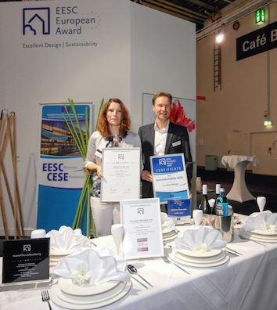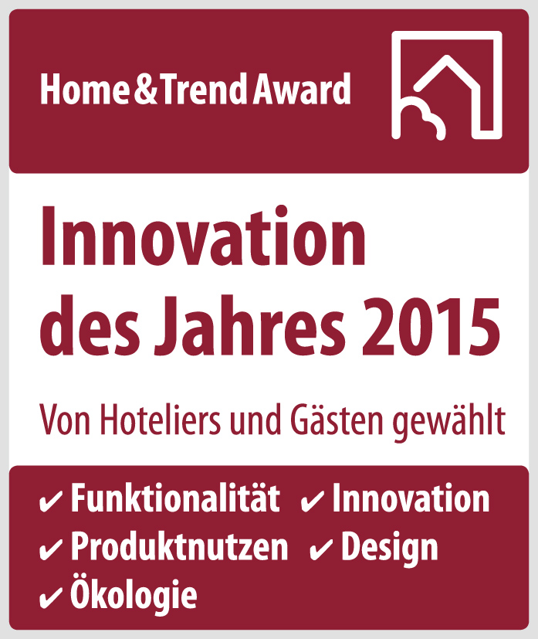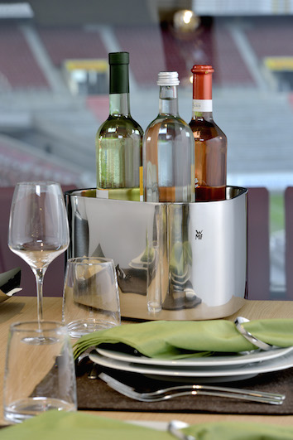
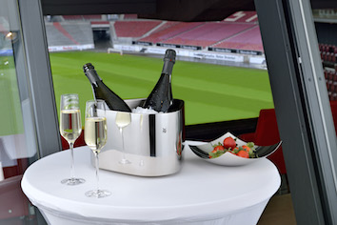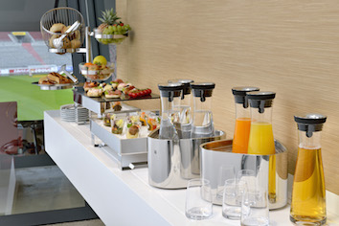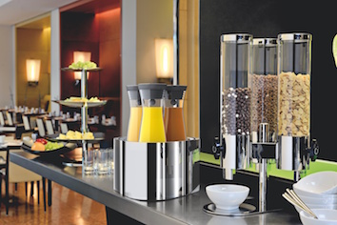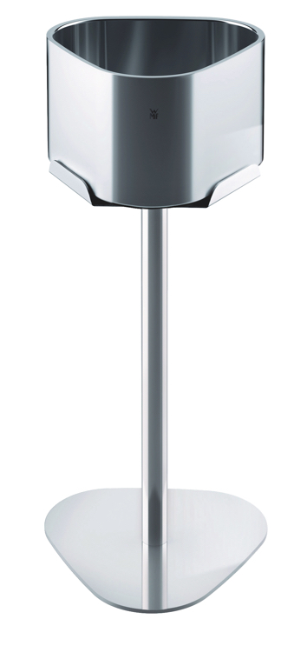

Additional information:  WMF Group GmbH  Thomas Dix, press spokesman  Eberhardstraße - 73309 Geislingen  Tel.: +49 73 31 25 8386  Fax: +49 73 31 25 8061  thomas.dix@wmf.de – www.wmf.de | Press and public relations  WMF press agency  c/o Press’n’Relations GmbH  Vanessa Klein and Monika Nyendick  Magirusstrasse 33 – D-89077 Ulm, Germany  Tel.: +49 731 96287-30 – Fax: +49 731 96287-97  wmf@press-n-relations.de – www.press-n-relations.de

About the WMF Group
WMF Hotel is one of the leading suppliers of professional hotel, catering and hospitality equipment. Stylish, high-quality complete solutions for every aspect of the art of presenting and serving food and beverages is the hallmark of the long-established brand. The extensive range includes cutlery and glassware, serving trolleys, buffet equipment and table-top decorations of every complexion.

For more than 160 years, the brands that make up the WMF Group have represented the best in cooking, drinking and dining. Every day, hundreds of millions of people around the world use WMF, Silit and Kaiser products to prepare food, cook, bake, eat and drink in the comfort of their own home. And when they are not doing that, they are enjoying coffee specialities and foods prepared by the hotel and catering industry using products from WMF, Schaerer or Hepp. Our employees are passionate about bringing people together, whether at home, on the move or at high-end restaurants, in order to give them shared moments that are both precious and delicious. This is all possible thanks to our products, whose exceptional design, perfect functionality and highest quality provide wonderful culinary experiences. Our company has a proud tradition, and was founded in Geislingen an der Steige in Germany back in 1853. Almost 6,000 employees provide culinary joy at more than 40 locations worldwide. The WMF Group achieved sales of EUR 1,024.3 million in 2014.

