press release

Birkenfeld, 10th April 2017

Artistic and functional buffets with HEPP
Expanded "Sequence" collection and new chafing dish induction GN 1/1

Over the last few years, HEPP has continued to expand its range of buffet solutions in order to be able to offer restaurateurs and hoteliers a harmonious overall concept with maximum flexibility of design. What's new in 2017: The "Sequence" collection that was honored with the German Design Award opens up even more possibilities for creative arrangements thanks to the nine new items. It now includes four stands in different sizes with two or three levels. Thanks to the different-sized inserts, the mix of materials predestined for Sequence can be arranged even more flexibly. Alongside, drinks coolers and ice trays keep the chilled refreshments at the right temperature, while practical holders for cutlery and labels guarantee a clear arrangement. Other new additions to the range from HEPP include the induction chafing dish (GN 1/1) in the "Excellent" and "Arte" designs with three different buffet stands – an ideal addition for warm and cold buffets. "With the new products, we are expanding the HEPP buffet offering and can offer our customers all-round solutions with greater flexibility, ensuring a tasteful presentation – this time with a special focus upon greater height at the buffet thanks to the new fruit stands," explains Susanne Schmidt, Head of Marketing and Product Management at proHeq GmbH.

Sequence: Boring buffets are a thing of the past
When it comes to the perfect combination of design, diversity and a secure investment, the "Sequence" buffet concept from HEPP is a real masterpiece. An attractive alternative compared with classic gastronorm (GN) systems, the asymmetric trapezium shape of the collection of 45 or so pieces convinces through both its high level of individuality and its easy handling in everyday use. The creative design of the buffet knows no limits – whether arranged in multiple parts, presented individually or combined with other HEPP buffet solutions. The pleasure of artistically arranging the dishes, plates and inserts is further enhanced by material combinations of wood, porcelain, stainless steel, Corian and fabric. Pedestals and stainless steel frames in various sights enable the flexible use of space and convenient removal of dishes. Last but not least, the innovative basic shape of the new collection is rounded off in style by different dishes, frames and plates in GN 1/1 size. Take a look at some of the countless possible variations on the website: sequence.hepp.de

Long-lasting freshness and the ideal temperature
With the Induction Plus series, HEPP offers the extremely flexible chafing dishes – now also available in size GN 1/1: They round off the product range sensibly and convince through their innovative technology. The stylish food warmers can be operated using fuel paste, hot plate or induction, depending on requirements, guaranteeing even and fast heat distribution. The beautifully-shaped chafing dishes are available in both the Excellent and Arte designs and with three different frames. Guests and staff are also delighted with how easy it is to use. The lid opens and closely very gently thanks to the innovative and long-lasting brake technology. The handles are heat resistant and the material, including inserts and removable glass lid, is all easy to clean and is dishwasher safe. The condensation recirculating system also provides for long-lasting freshness.

www.hepp.de

Image request
Images can be downloaded from our media portal http://press-n-relations.amid-pr.com. Just search for "HEPP Buffet 2017".

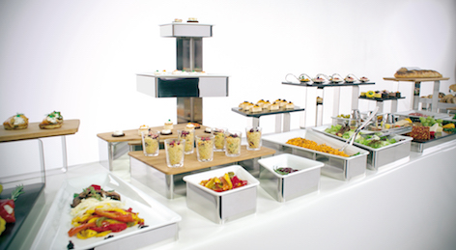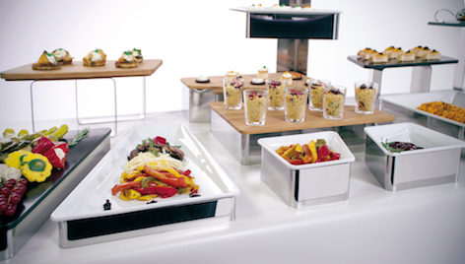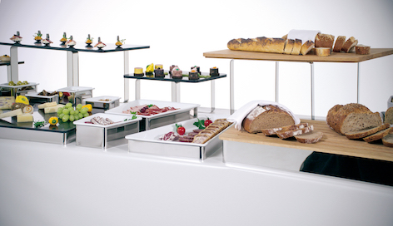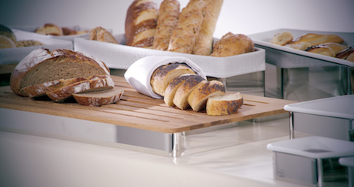
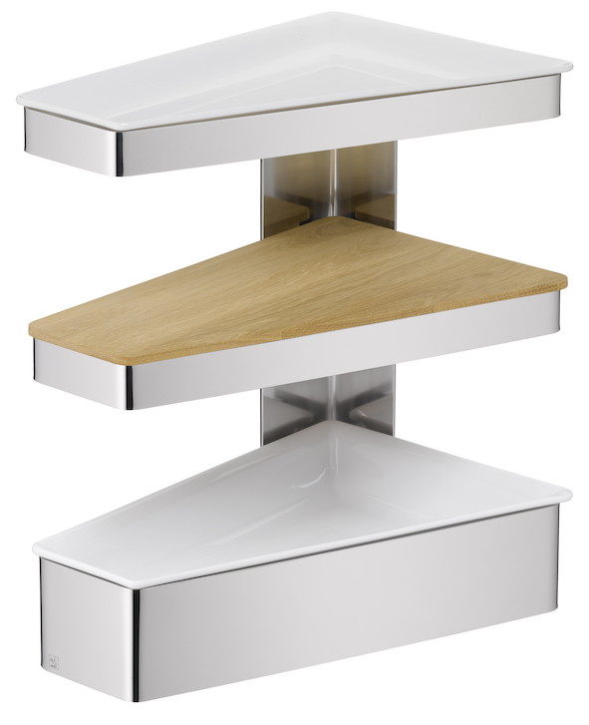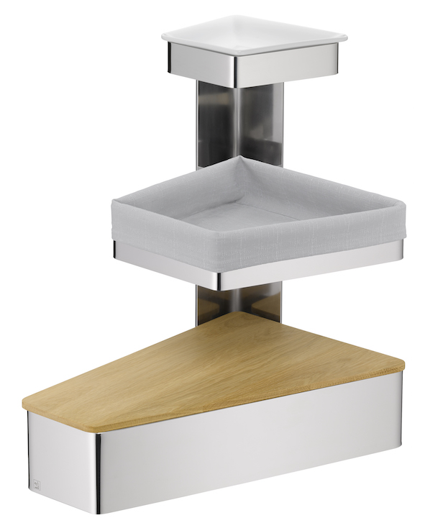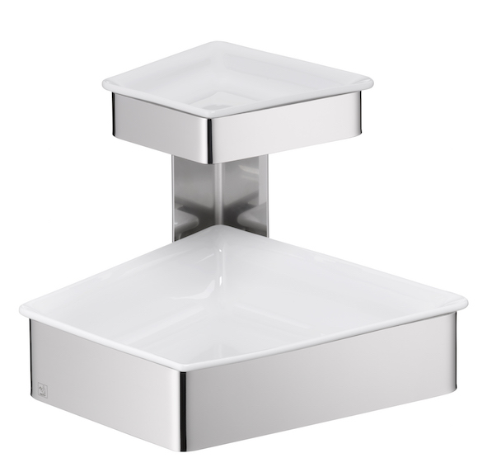
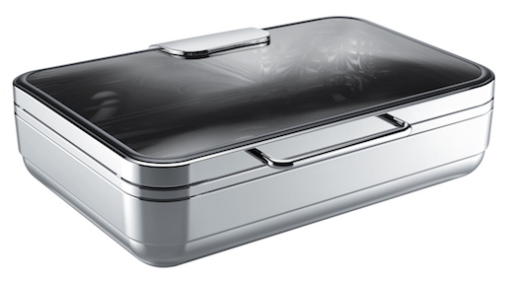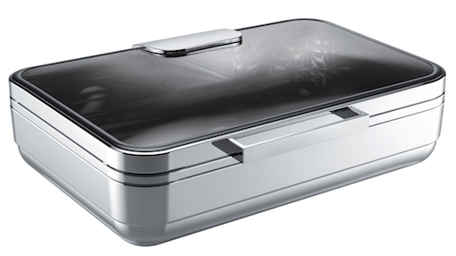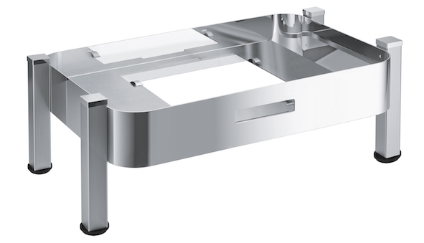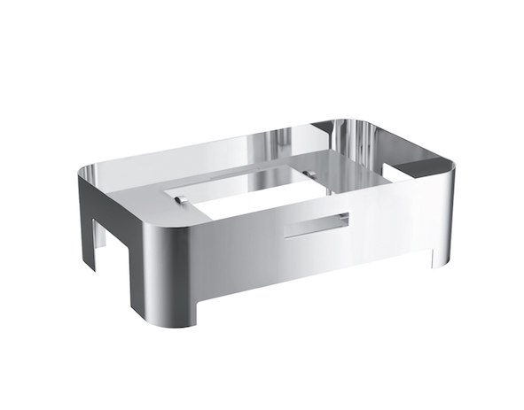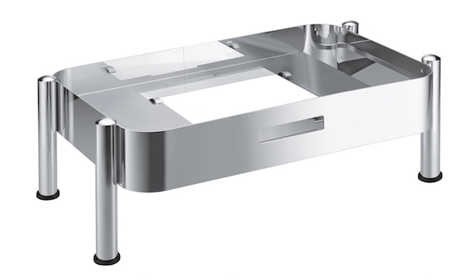

Further information:  proHeq GmbH  HEPP  Carl-Benz-Strasse 10  D-75217 Birkenfeld  Tel. +49 7231 4885 0  Fax +49 7231 4885 83  hepp@press-n-relations.de  www.hepp.de | Press and Public Relations:  Press’n’Relations GmbH  Vanessa Klein and Monika Nyendick  Magirusstraße 33 – D-89077 Ulm  Tel. +49 731 96287-20  Fax +49 731 96287-97  hepp@press-n-relations.de  www.press-n-relations.de

About HEPP
HEPP – Professional Hotel Equipment, proHeq GmbH – based in Birkenfeld near Pforzheim, is one of the leading international providers of tableware. The company uses highly specialized manufacturing processes to produce the world's most diverse range of tableware and serving equipment – from cutlery, coffee pots and the like to chafing dishes and food distribution systems. The focus is upon the material and workmanship, but the design, quality and high level of functionality of HEPP products also meet the highest demands. In 1863, the brothers Carl and Otto Hepp founded the company under this premise and are therefore rightly considered the inventors of hotel silverware. The traditional values of reliability and quality still apply today and form the basis for the success of the company in combination with innovative strength, the development of new processes and products and flexible manufacturing. Globally, HEPP is one of the preferred outfitters of leading hotels, hotel chains and restaurants, as well as quality-conscious major catering firms, international cruise lines, airlines and railway companies.

